Last Updated: 2/12/2024
This Quick Reference Guide (QRG) is intended to assist individuals who have been assigned the role of Compensation Manager as part of the annual merit process. Please note, Chrome is the preferred browser for accessing Compensation worksheets and merit processes in SuccessFactors.
Purdue uses an online tool within SuccessFactors to manage the annual merit process.
- If you have been assigned the role of Compensation Manager, it is your responsibility to enter recommended merit increases into a worksheet within the SuccessFactors compensation module for employees that have been assigned to you.
- These recommended increases must be entered timely and should follow Purdue’s compensation guidelines and the annual merit policy. Please click ‘Save’ often, as you proceed through the worksheet.
- Compensation Managers will receive a SuccessFactors workflow notification when the merit worksheet has been created and is ready for entry.
- Once entry of the recommended increases is complete, Compensation Managers will submit the worksheet for review. SuccessFactors will automatically notify the Compensation Manager assigned to you (One-Up Compensation Manager) that the worksheet is complete and ready for review and approval.
  - You may hold both a Compensation Manager role and a One-Up Compensation Manager role.
  - The Approving Merit Worksheets – One-Up Compensation Manager QRG provides guidance on the approval process.

Contents (Quick Links)
Merit Planning Process Diagram 1
Pre-Merit Planning Reports 2
Merit Planning Employee Validation Report 2
Access SuccessFactors; Access Compensation Home 2
Merit Worksheet Tour 3
Top Menu Bar 3
Worksheet Column Highlights 4
Bottom Menu Bar 6
Enter Merit 7
Post-Merit Planning Reports 8
Export Merit Worksheet 8
Export Detailed and Rollup Reports 8
Viewing Batch Processed Reports 11
Revising Sent Back Worksheets 11
Viewing Worksheet Approval Status Information 12

Merit Planning Process Diagram

Pre-Merit Planning Reports
The section below outlines the reporting and exporting capabilities that can assist Compensation Managers as they prepare for the Merit Planning process and during the process.

Merit Planning Employee Validation Report
Compensation Managers may wish to run this report if:
- They are tasked with entering merit information for a large number of employees whose personnel details they are not familiar

The Merit Planning Employee Validation Report can be provided by your Business Manager or Director of Financial Affairs. The report returns additional personnel details for each individual that the Compensation Manager is responsible for, which may be helpful when completing the Worksheet. (Example: Determining if individuals are only eligible for prorated merit increase due to hire date.)
Some notes on fields found in the report:
Position Entry Time | This field displays the hire date for the individual’s current position. If 12/24/2019 or 1/1/1900, the individual was hired into their current position before the transition to SuccessFactors. If 1/1/2019 was listed, the individual was hired into their current position before the transition to SuccessFactors, OR they were hired on 1/1/2019.
Salary Band Analysis | Indicates if individual is Below, Within, Close to Over (within 3% below the top of the salary range), or Over the Salary Range for the position,
Benefit Premium Review | Indicates if the individual is close approaching the current Benefit Premium threshold. (Returns “Yes” if individual’s annual salary is within 3% of the threshold)
Concurrent Flag | This indiciates that the individual holds multiple positions. Consult with your area’s Executive Reviewer (DFA) for assistance coordinating Merit Increases between departments.

Access SuccessFactors; Access Compensation Home
Compensation Managers receive an email when there is a Merit Planning Worksheet available for their input. The email contains a link to access the Worksheet. The steps below are an alternative way to access the Worksheet.
Individuals with multiple positions may encounter issues clicking the link in the email message. Please use the instructions below.
Via the OneCampus portal (one.purdue.edu), select Employee Launchpad

Log in using Purdue Career Account ID and password.
Click the Plan Compensation To-Do tile,  or | 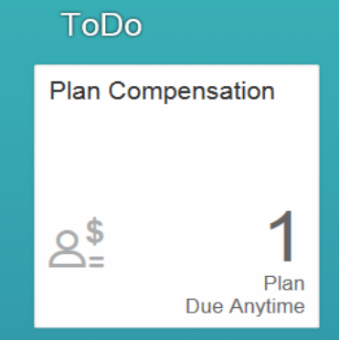
If you hold multiple positions and do not see the Plan Compensation tile, use the Change Selected Employment menu to select the appropriate position. | 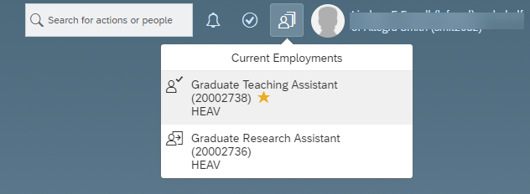
From the Home drop-down menu, select Compensation | 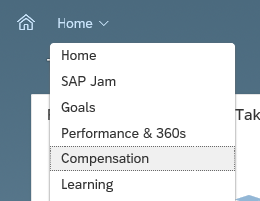

Merit Worksheet Tour

Top Menu Bar
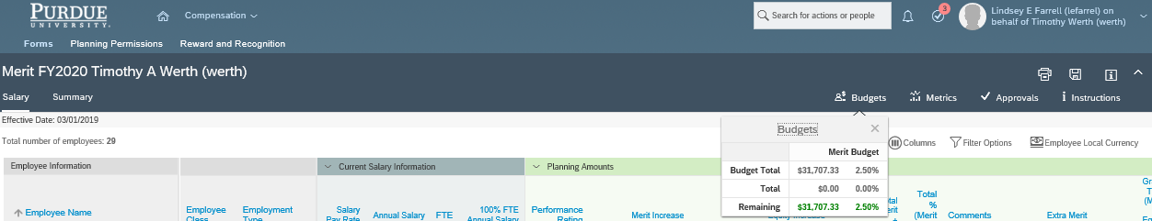
7
1
5
6
4
2
3

1 | The Budgets widget displays Budget Total allocated to you, the Total already allocated through your work on the sheet, and the amount Remaining.  The Budgets widget can be clicked, dragged, and placed anywhere on the screen so that it is aways visible.
2 | The Metrics widget displays the following data for the individuals on the worksheet: Performance Distribution, Pay/Performance Matrix, and Merit Increase to Performance Rating. Compensation Managers should consult this widget to ensure a consistent application of merit increases compared to performance rating.
3 | The Approvals tab displays the step of the merit process at which the worksheet currently resides, and the subsequent steps in the process.
4 | The Instructions tab links users to the location of references and information that can assist in completing the worksheet and the guidelines and policies that govern Compensation / Merit Increases.
5 | The Columns icon allows the user to hide or show columns on the worksheet
6 | The Filter Options icon allows the user to filter the data in the worksheet by various personnel attributes including name, Department, Division, Performance Rating, etc.
7 | To Sort, click any blue column label.

Worksheet Column Highlights
The worksheet contains many columns divided into sections. Some columns are informational and some are used to enter merit increase data. This section outlines the columns requiring additional explanation.
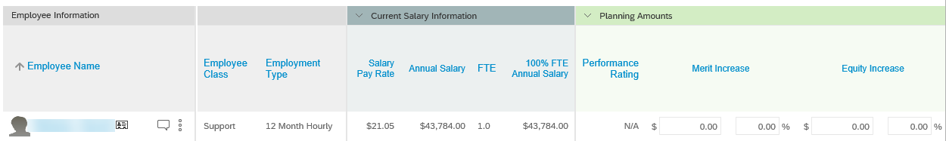
Section | Column Name | Notes (if applicable)
Employee Information | Employee Name | To view additional information related to the employee, click the Business Card icon next to their name, or see the Additional Information columns on the far right end of the worksheet.
Current Salary Information | Salary Pay Rate | Displays the pay rate per pay period (may be biweekly or monthly)
 | 100% FTE Annual Salary | When reviewing Current Salary Information, it is important to consider individuals with FTEs less than 1.0 and individuals with Academic Year appointments.
 | FTE
 | Annual Salary
Planning Amounts | Performance Rating | Click the rating to view the individual’s performance documentation.  The performance rating is imported from the Performance module.
 | Merit Increase  ($ and %) | Use these fields to input a merit increase amount for each individual. Enter in the $ or % column, the other column will auto-populate.  This field draws from the budget.  Comment Required in Comment field If:  - NO merit increase  - Examples: “Hire Date Restriction”, “Performance”, “Resigned”, “Retiring”  - Merit increase of greater than 8%  - Examples: “Performance” or “Equity”
 | Equity Increase  ($ and %) | This field is rarely used. If you believe you have reason to use this field, please consult with your area’s Compensation Specialist. This field draws from the budget.
 | Extra Merit ($ and %) | Extra merit is typically entered by the Executive Reviewer.  If applicable, use these fields to input extra merit. Enter in the $ or % column, the other column will auto-populate.  This field draws from the budget.
 | Comments | Comments are be visible to all reviewers. Take care to avoid sensitive or personal comments, and comments that violate HR policy. Comment fields are limited to 500 characters.  Comment Required in Comment field If:  - NO merit increase  - Examples: “Hire Date Restriction”, “Performance”, “Resigned”, “Retiring”  - Merit increase of greater than 8%  - Examples: “Performance” or “Equity”
Section | Column Name | Notes (if applicable)
Lump Sum | Lump Sum | This field draws from the budget.
Promotion | Faculty/Staff Promotion ($ and %) | Reflects any promotions entered. Since promotions are pre-loaded, this field is not editable.  This field does not draw from the budget.
Current Admin Adjustment | Administrative Adjustment Date | The date that the current Admin Adjustment began.
Planning Admin Adjustment | Annual Admin Adjustment Amount ($ and %) | Use these columns to add or change administrative adjustments. The fields will be gray for individuals not eligible for Admin Adjustments.  Enter in the $ or % column, the other column will auto-populate.  - Entries in these columns will overwrite the Current Admin Adjustment columns.  - To carry forward an admin adjustment, the current amount must be entered.  - To update an admin adjustment, enter the new amount.  - Admin Adjustments cannot be removed as a part of this process. (Entering zero will stop the pay but will not cancel the wage type in Success Factors. Follow admin adjustment process to remove wage type)  This field does not draw from the budget.
Comments | Comments | Comments are be visible to all reviewers. Take care to avoid sensitive or personal comments, and comments that violate HR policy.  - If adjusting or not carrying an Admin Adjustment forward, a comment is required.  - If total increase is 0% or more than 8%, a comment is required.  - Comment fields are limited to 500 characters.
New Salary Information | Total Annual Increase | Reflects all increase (Merit, Equity, Extra Merit)
 | Final 100% FTE Annual Salary | Reflects annual base salary after all entries at 100% FTE.
Pay Range Information | Salary Range | Salary Ranges are determined based on market value for the position. Sources of market data vary by position.  - Salary Range data for Executives, Faculty, and Researchers is very broad and should not be used for planning purposes.  - Salary Range data for individuals with less than a full time fiscal year appointment may appear skewed.
 | Current Compa-ratio | The comparison of the individual’s full time equivalent salary to the market rate for the position. (Examples: 100% Compa-ratio indicates that the individual’s salary is at the market rate. 75% indicates that the salary is 25% below market rate. 125% indicates that the salary is 25% above market rate.)  - Compa-ratio data for Executives, Faculty, and Researchers is not meaningful because of the broad Salary Ranges associated with them and therefore should not be used for planning purposes.  - Compa-ratio data for individuals with a academic year appointment may appear skewed.  - Color Key  - Green = less than 85%  - Yellow = 85-115%  - Light Red = greater than 115%
 | New Compa-ratio | Reflects Compa-ratio after data from worksheet is applied.  - Green = less than 85%  - Yellow = 85-115%  - Light Red = greater than 115%
 | Current Range Penetration | The position of the employee’s pay within the pay band. (Examples: A range penetration of 50% means the individual’s salary is at the median or market rate. A range penetration over 100% means that the individual’s salary is above the maximum of the pay band.)  - Color Key  - Green: 45-55  - Light Green: 40-45 or 55-60  - Yellow: 30-40 or 60-70  - Orange: 20-30 or 70-80  - Red: Less than 20 or more than 80
 | New Range Penetration | Reflects Range Penetration after data from worksheet is applied.  - Color Key  - Green: 45-55  - Light Green: 40-45 or 55-60  - Yellow: 30-40 or 60-70  - Orange: 20-30 or 70-80  - Red: Less than 20 or more than 80
Additional Information | Publish Date | Effective date of the merit increase.
 | Emp User ID | Personnel Number (PERNR)
 | Job Title | Internal Job Title Classification
 | Service Date | Original Purdue Hire Date. This is not the hire date for the individual’s current position. The Service Date may be adjusted if an individual has left and returned.
 | Faculty Rank | Reflects faculty rank as displayed in Success Factors profile.

Bottom Menu Bar
1 | Items per page allows the user to change the number of rows displayed. This can be helpful if the user wishes to view all lines (or up to 100 lines) on one page and avoid navigating between pages.
2 | The Page arrows allows users to navigate between any additional pages of the worksheet.
3 | Send to Next Step advances the worksheet to the approver.
4 | Clicking Cancel clears all unsaved data entered in the worksheet.
5 | Use the Save button often to avoid losing data. Ensure that Save operation is complete before moving forward. Always save before navigating to a new page. SAVE OFTEN.

Enter Merit
For each individual listed on the worksheet, complete all appropriate fields. Please review all details in the Merit Worksheet Tour section of this document to understand the function and/or required data entry for each field.
- Note: If you wish to export the worksheet please see the Export Merit Worksheet section. Compensation Managers cannot import worksheets.
- Ensure that the entries are accurate and align with the annual merit guidelines. Use the Budget tool to ensure that your entries are within the amount allocated.
Click Save | 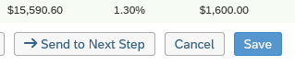
Review any warnings that may appear (over budget, for example)  Click OK  Revise as needed. Save again. | 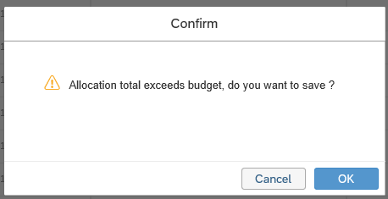
Click Send to Next Step

Note: After clicking this button, the Comp Manager cannot edit the worksheet. Ensure that all fields are complete (as needed) for all individuals listed on the worksheet.
Review the Route Map.  Click the Information icon next to each step to review details regarding the individual responsible for each step. | 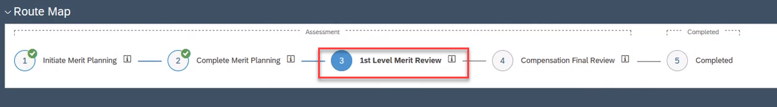
Enter any Comments for the reviewer.  Click Send to Next Step  The Compensation Manager’s Compensation Manager (One-Up Compensation Manager) will receive an email notification to review the worksheet.  If you also hold the role of One-up Compensation Manager, the Approving Merit Worksheets QRG provides guidance on how to approve worksheets that are sent to you. | 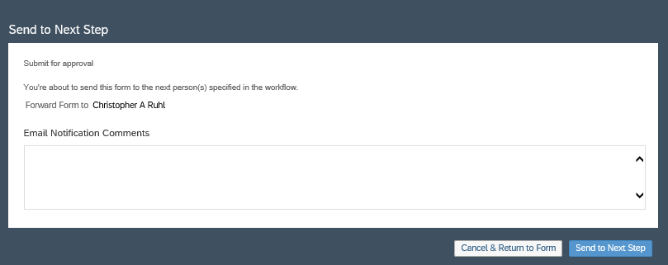
Track the status of the worksheet on the My Forms page.  Click En Route to locate worksheets still in the approval process. | 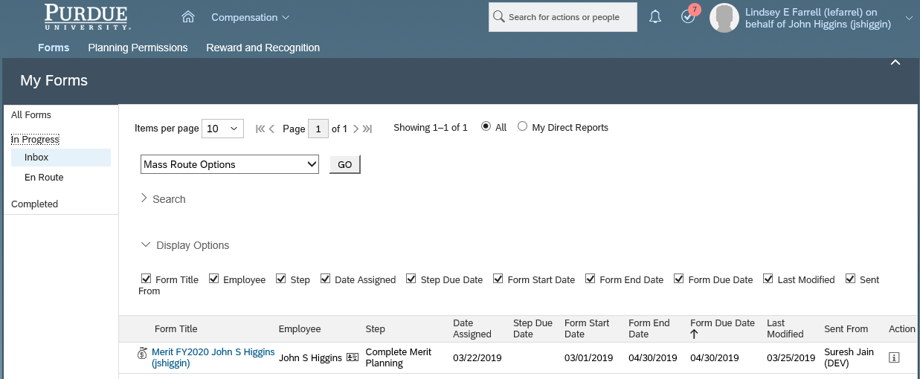

Post-Merit Planning Reports
This section outlines the reporting and exporting functionalities available to Compensation Managers during and following the Merit Planning process.

Export Merit Worksheet
If you wish to export the worksheet to review the information, please follow the step below.
Note: Worksheets cannot be imported.
Click the Summary tab.  Click Export as MS Excel. |  |  | 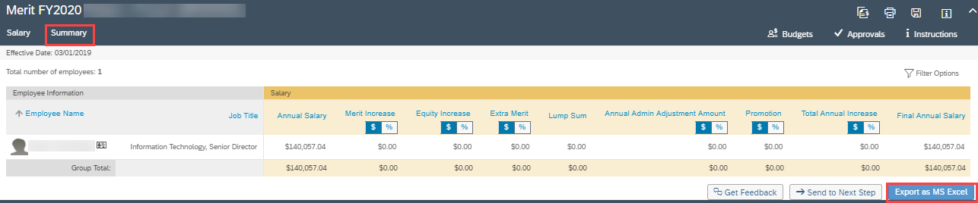

Export Detailed and Rollup Reports
These reports provide the aggregate of total values of all users in the Compensation Manager hierarchy below the individual selected. The reports allow for drill-down to other users and review of specific Compensation worksheets. These reports cannot be edited and imported back into the Compensation module.
- From the Home menu, select the Compensation module  - Click the Forms tab  - Select All Forms |  | 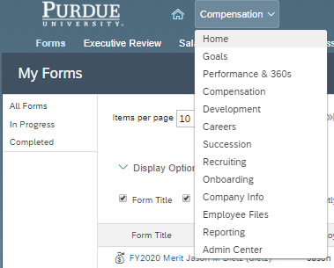  3  2  1
In the Action column, click the Detailed Report icon  () |  | 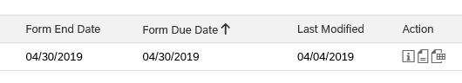
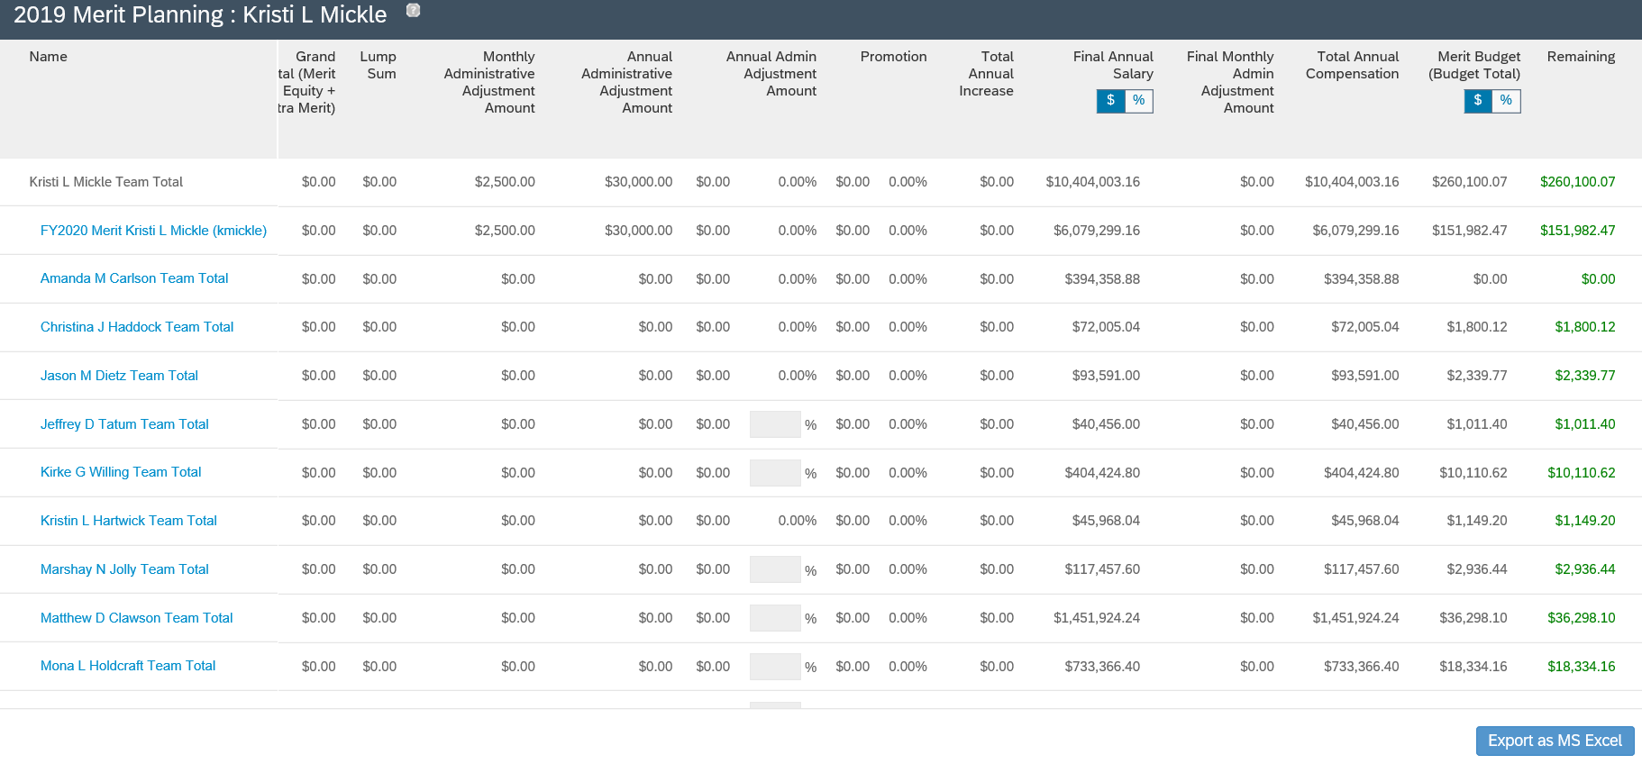
4
3
2
1
The Team Totals report is displayed for yourself and all Compensation Managers below you (in the Compensation Manager hierarchy). Some helpful features of the report are:
1 | Click each Team Total link to drill into the worksheets.
2 | Option to view the data in $ or %
3 | Columns found on the far right of the worksheet outline the budget utilized and remaining
4 | Option to Export to MS Excel (additional details on this process begin with the next step of this document)
To export a detailed and rollup version of this report, click Export as MS Excel |  | 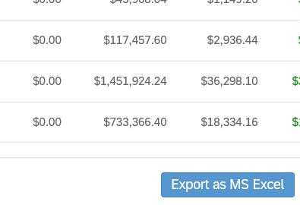
If an error message is displayed stating that the report has been scheduled for batch processing, see the Viewing Batch Processed Reports section of this document.  This message is typically displayed when more than 1000 records are being exported. |  | 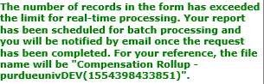
Save the zipped folder.
Two reports will appear in the folder:  - Compensation Rollup - Details  - Compensation Rollup - Rollup |  | 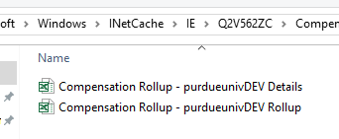
Compensation Rollup – Details displays the expanded view of all worksheets listed and all individuals listed on each worksheet. |  | 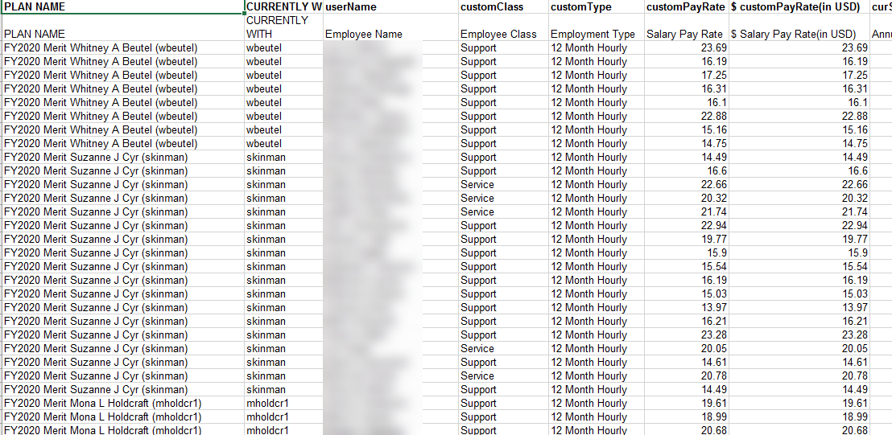
Compensation Rollup – Rollup displays the rollup of each Compensation Manager’s worksheet listed (no individual detail), with budget used, percentage, and budget remaining. |  | 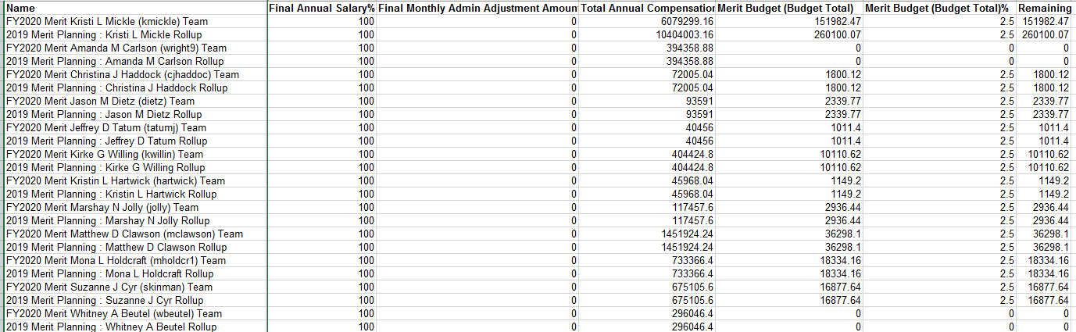

Viewing Batch Processed Reports
If attempting to export a large report, it may be scheduled for batch processing. This section outlines how to retrieve the report.
Use the Home menu to access the Reporting module. | 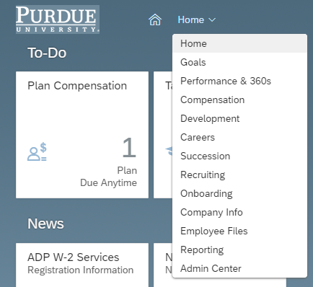
Click Switch to Classic View
Click Scheduled Reports  The report(s) are listed.  Locate the Download column of the line representing the desired report and click zipped to download the files. | 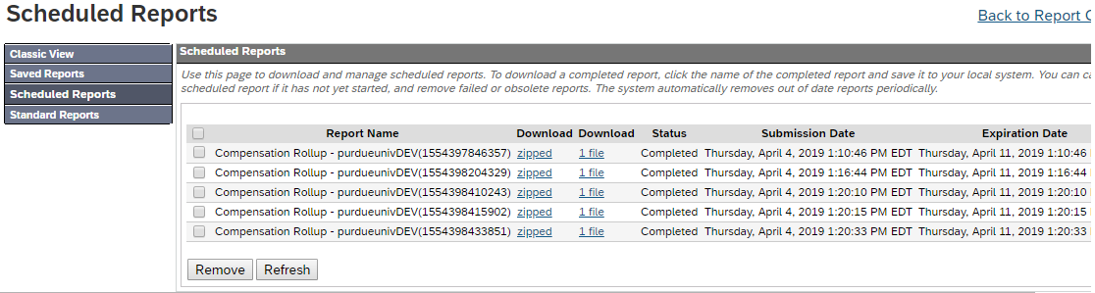

Revising Sent Back Worksheets
If the One-Up Compensation Manager sends the worksheet back with edits requested, the Compensation Manager will receive an email notification to access SuccessFactors to make the adjustments. Access the worksheet as described in the Access SuccessFactors; Access Compensation Home section and enter the changes as requested.
Refer to the Merit Worksheet Tour and Enter Merit sections as needed.

Viewing Worksheet Approval Status Information
Status of Forms are always available in the My Forms section.
If you identify that changes are needed after you have sent the worksheet to the next step, work with your One-Up Compensation Manager and/or Executive Reviewer (Business Manager or DFA).
- From the Home menu, select Compensation  - In the menu bar, click Forms | 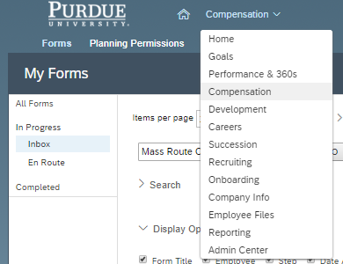
Completed: Forms have been submitted to the Compensation team and accepted (forms will not show as Completed until after the worksheet due date – all will be accepted at the same time).  En Route: Forms are pending approval with the individual listed in the Currently With column. | 